Task 3 Output

Color, k=5, svd

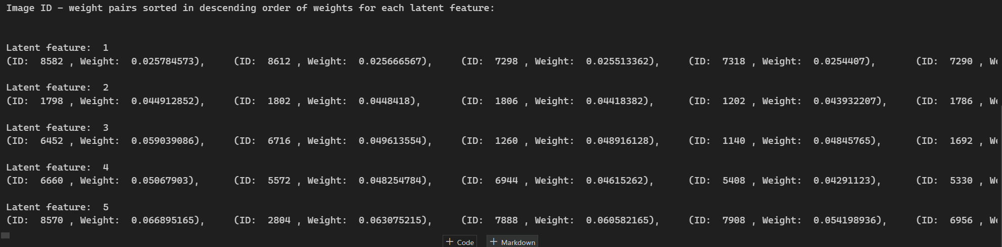

Color, k=5, nnmf

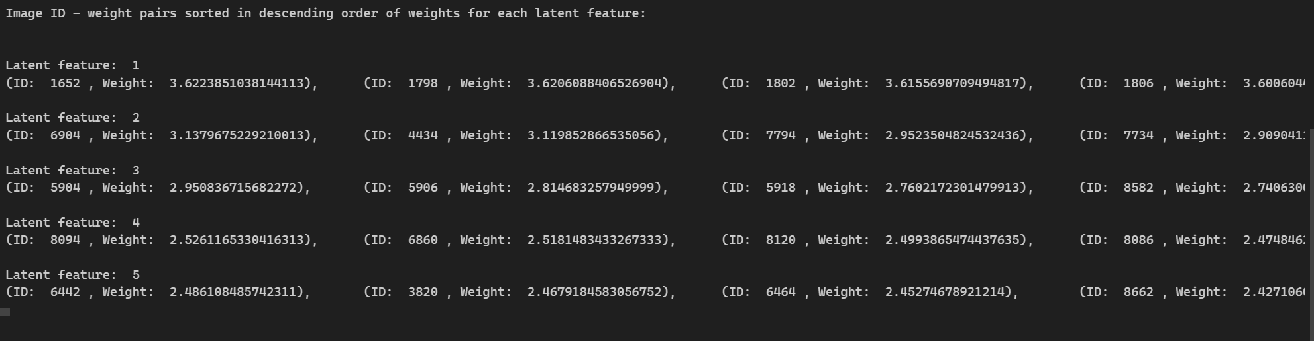

Color, k=5, lda

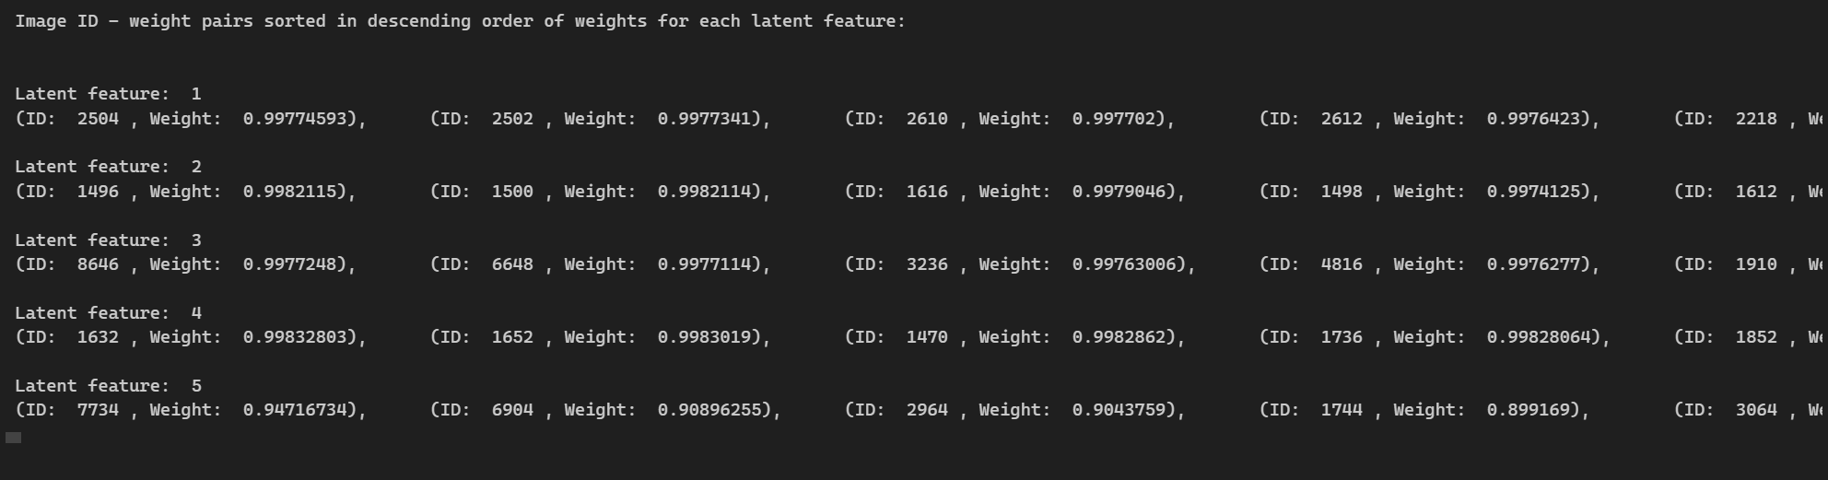

Color, k=5, kmeans

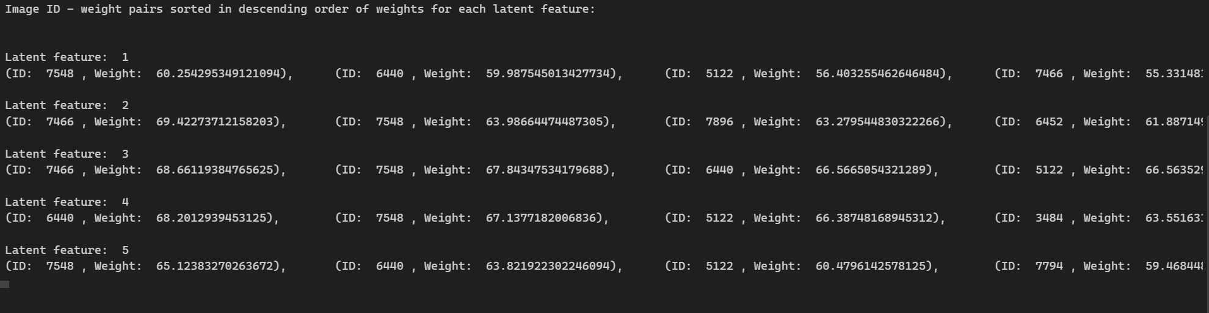

resnet, k=5, svd

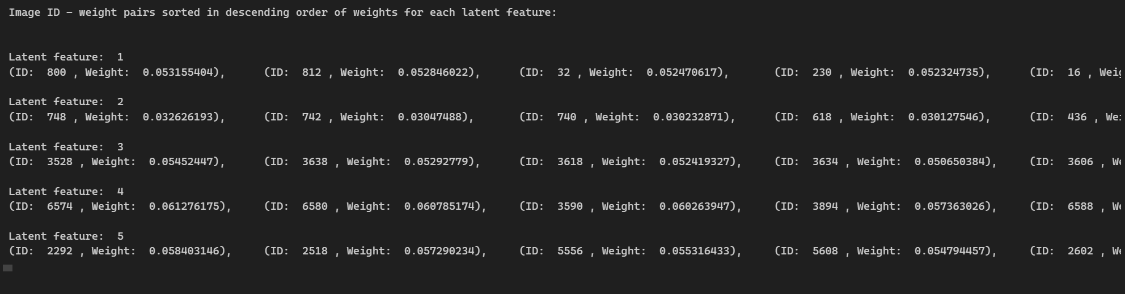

resnet, k=5, nnmf

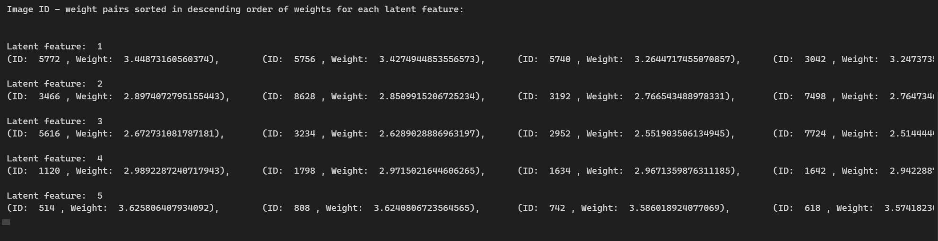

resnet, k=5, lda

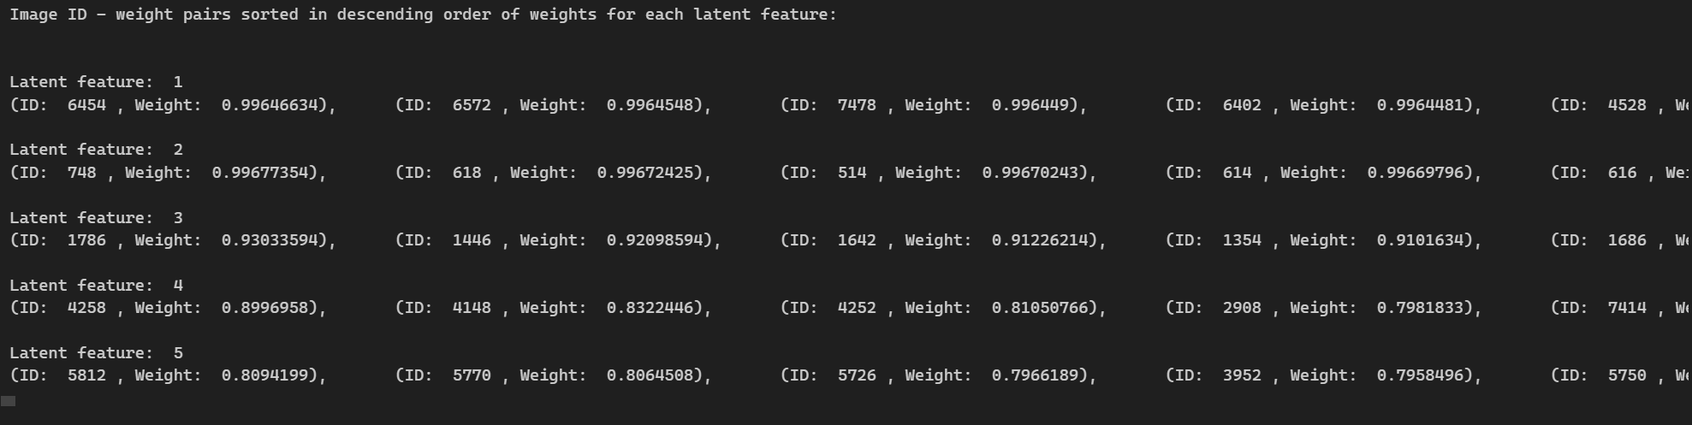

resnet, k=5, kmeans

